|  |  |
| --- | --- |
|  | Diagrams |
|  |  |
| Generated 3.5.2020 г. | Rezervito |
|  |  |

Rezervito_Context (Rezervito_Context.ndx)

From Rezervito Package

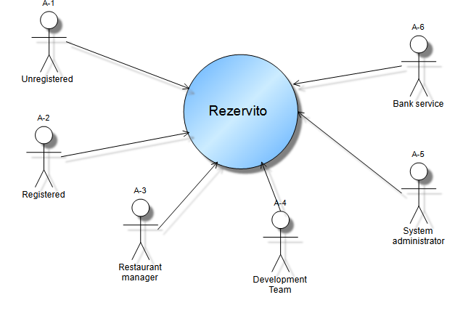

Unregistered Client Use Case (Unregistered Client Use Case.ndx)

From Unregistered Client Use Case Package

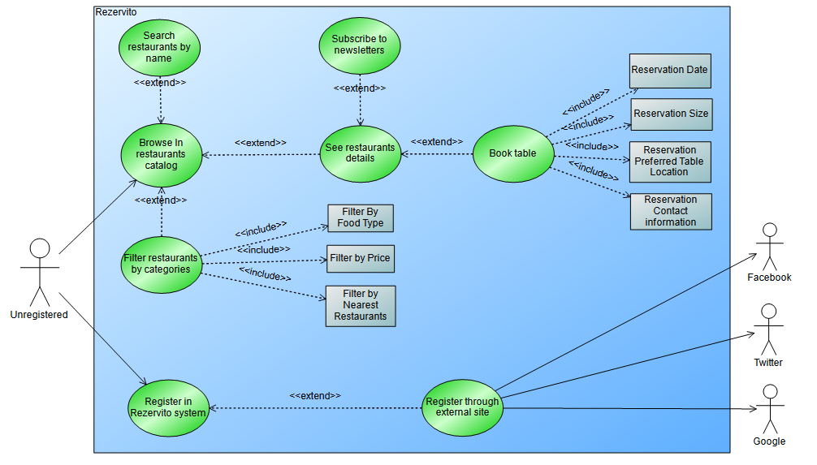

Registered Client Use Case (Registered Client Use Case.ndx)

From Registered Client Use Case Package

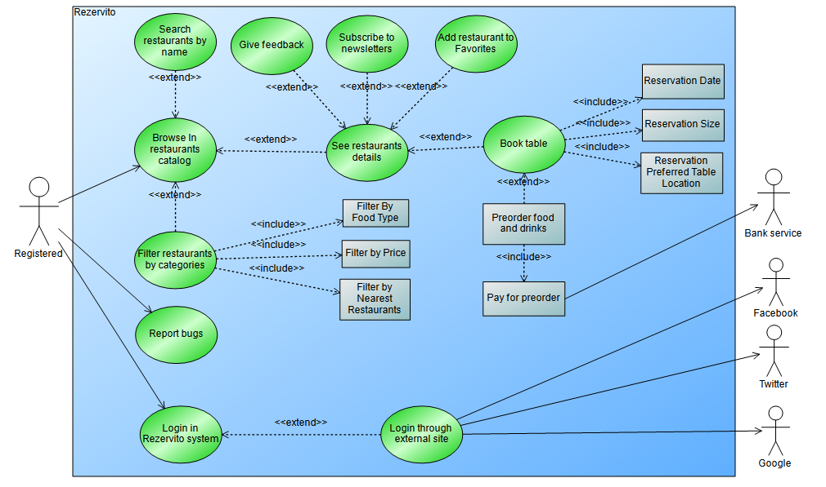

Restaurant Manager Use Case (Restaurant Manager Use Case.ndx)

From Restaurant Manager Use Cases Package

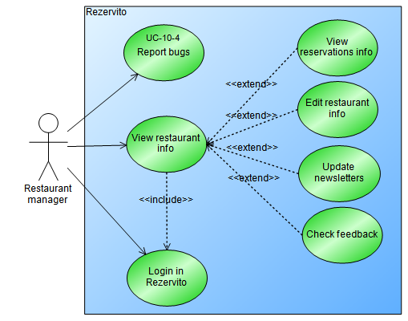

System Administrator Use Case (System Administrator Use Case.ndx)

From System Administrator Use Cases Package

